8085 SIMULATOR PROGRAMS

1. ARITHMETIC OPERATIONS
a) ADDITION WITH CARRY USING DIRECT ADDRESSING
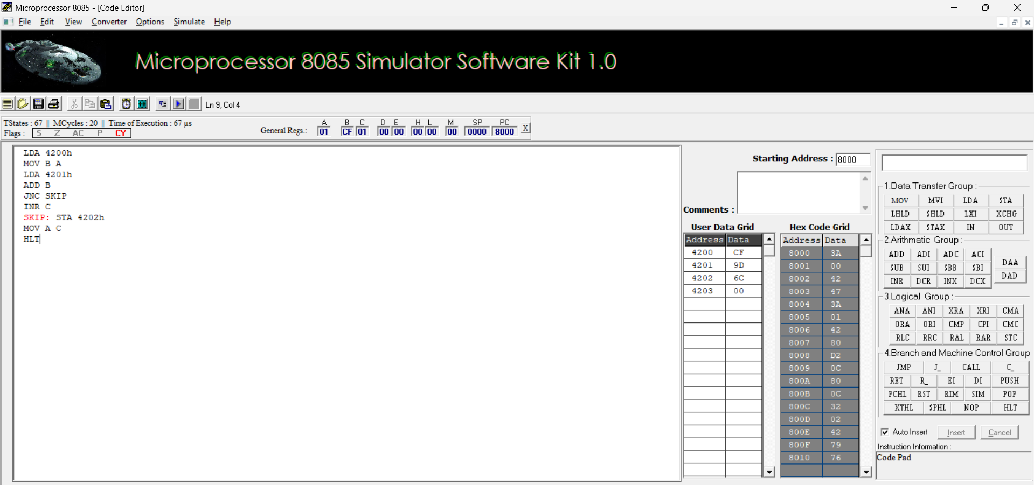
b) ADDITION USING INDIRECT ADDRESSING
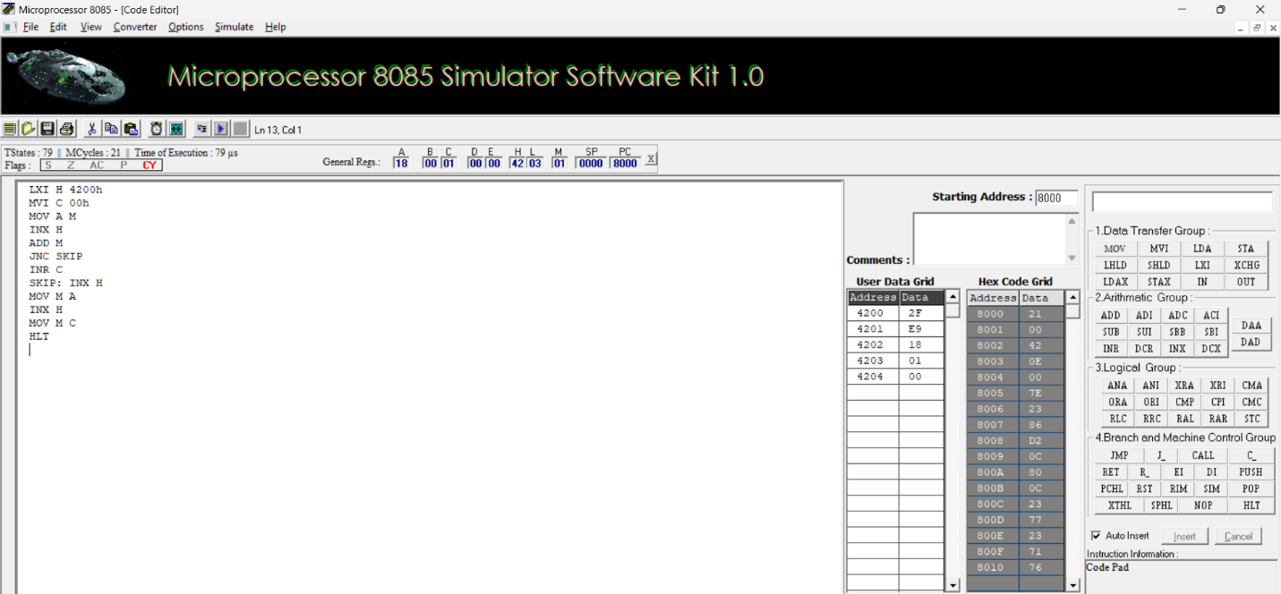

c) SUBTRACTION WITHOUT BORROW
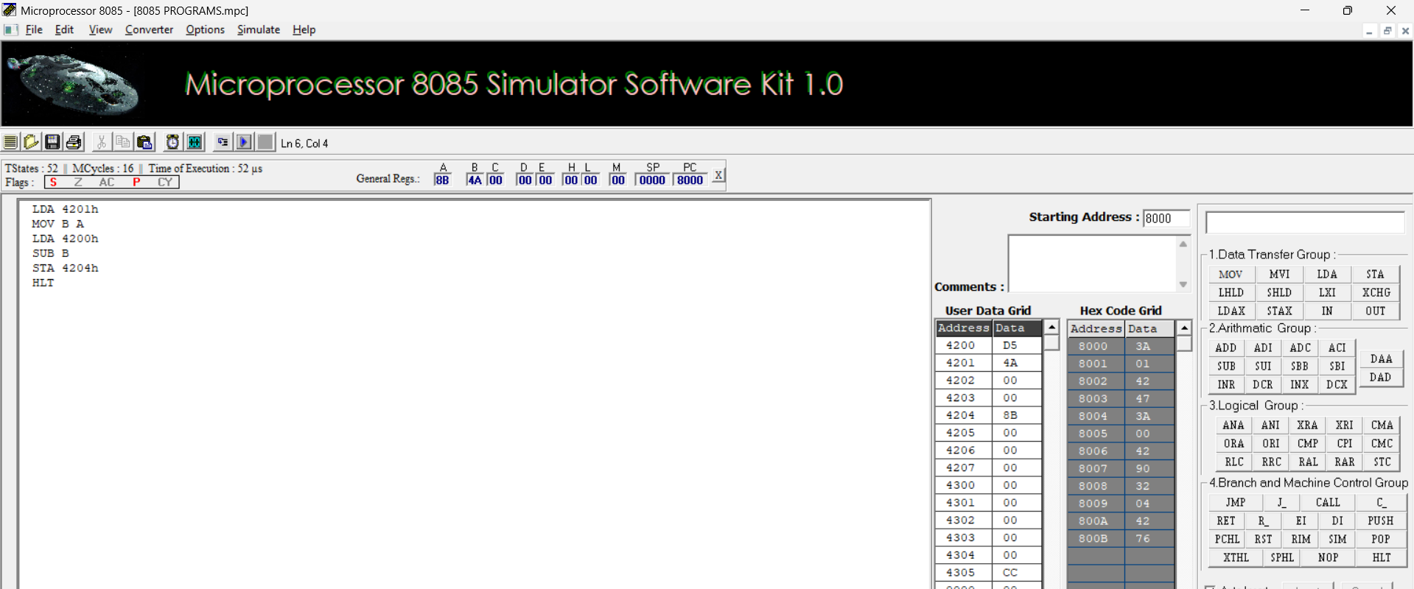
d) SUBTRACTION WITH BORROW USING DIRECT ADDRESSING
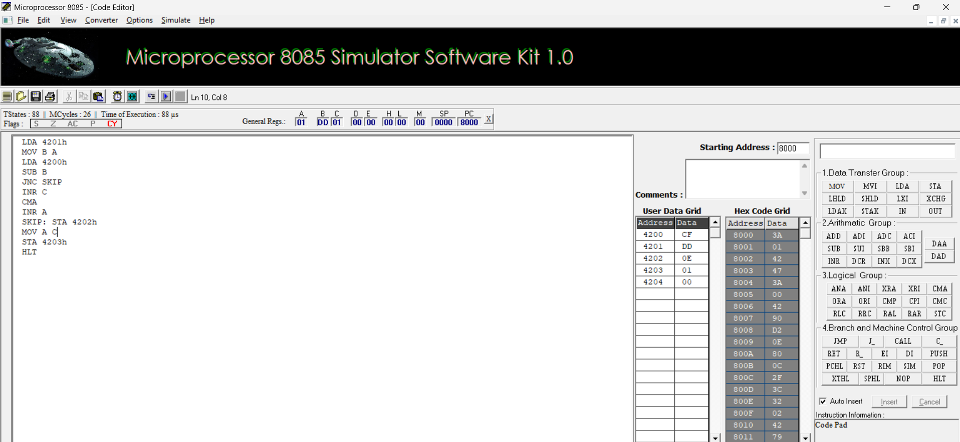

e) MULTIPLICATION
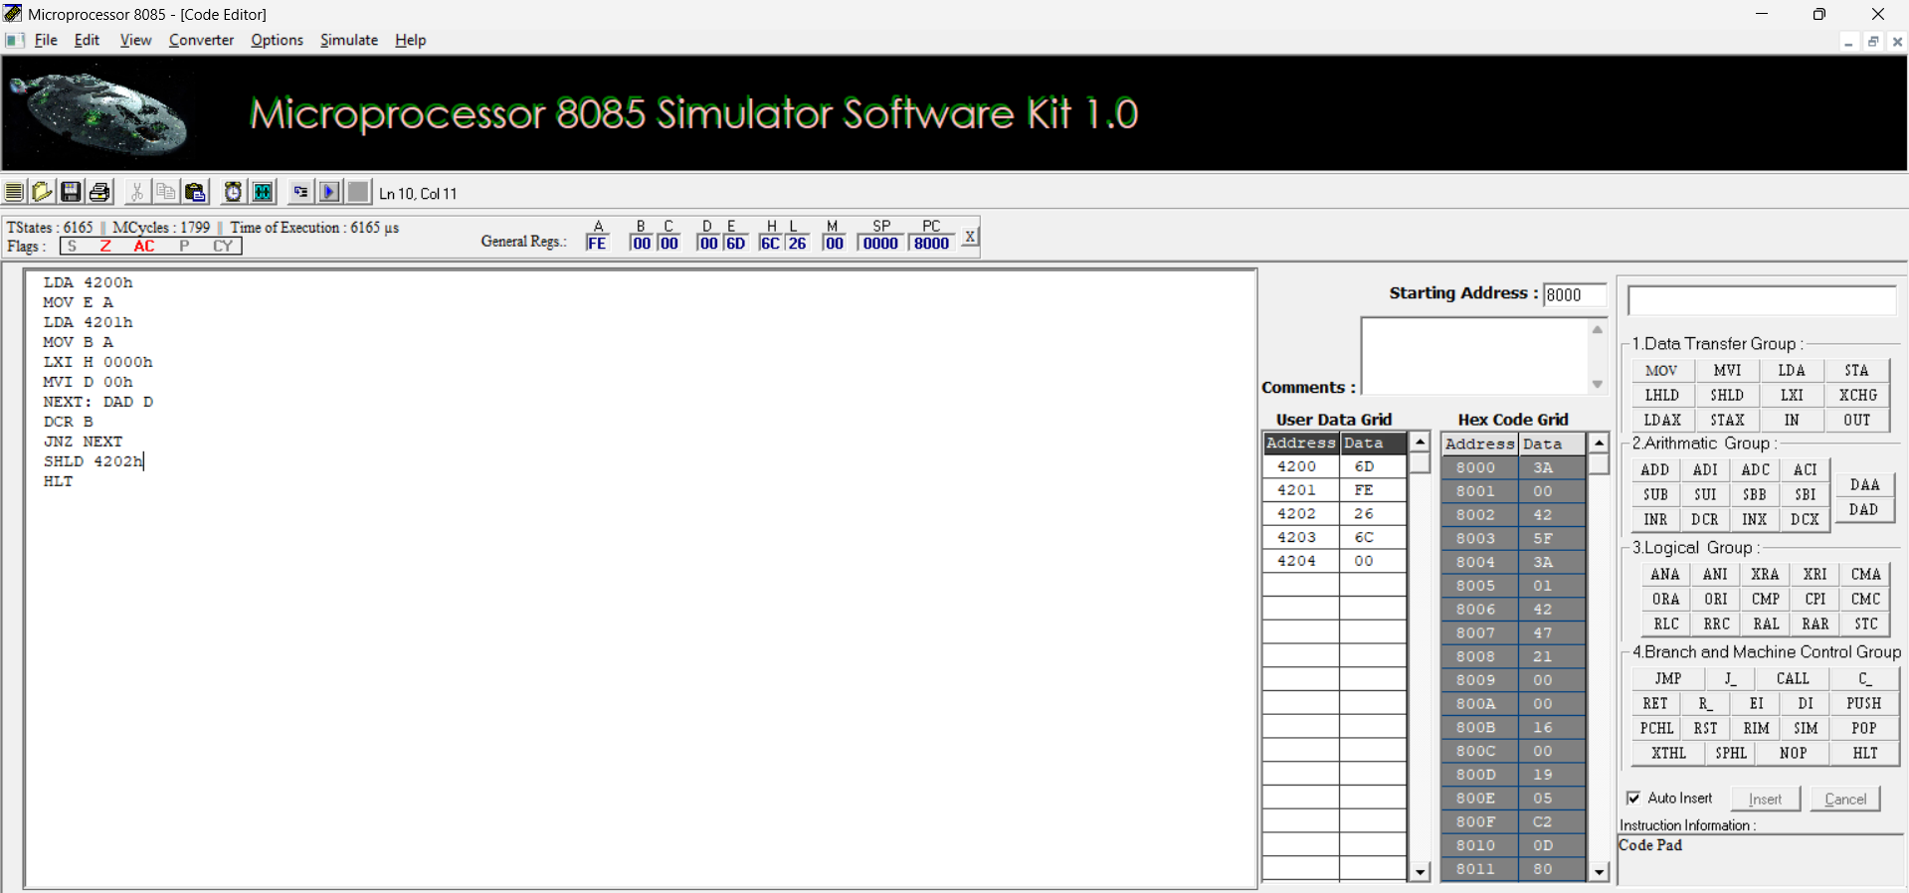

f) DIVISION
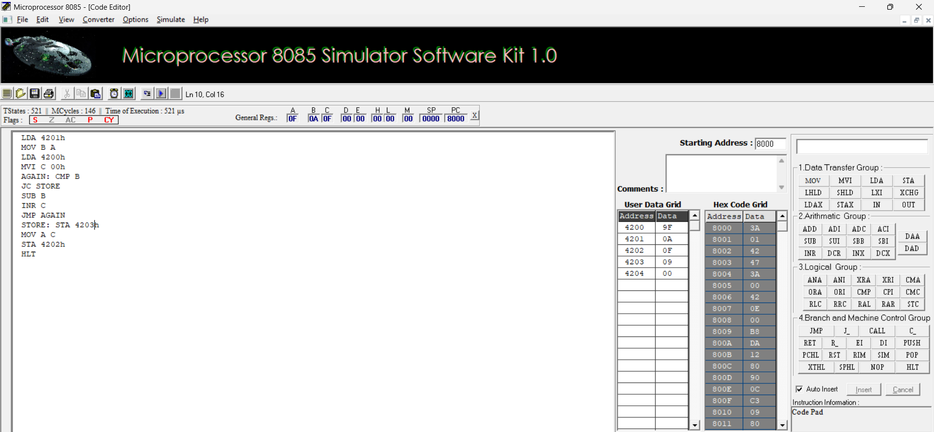

2. ASCENDING
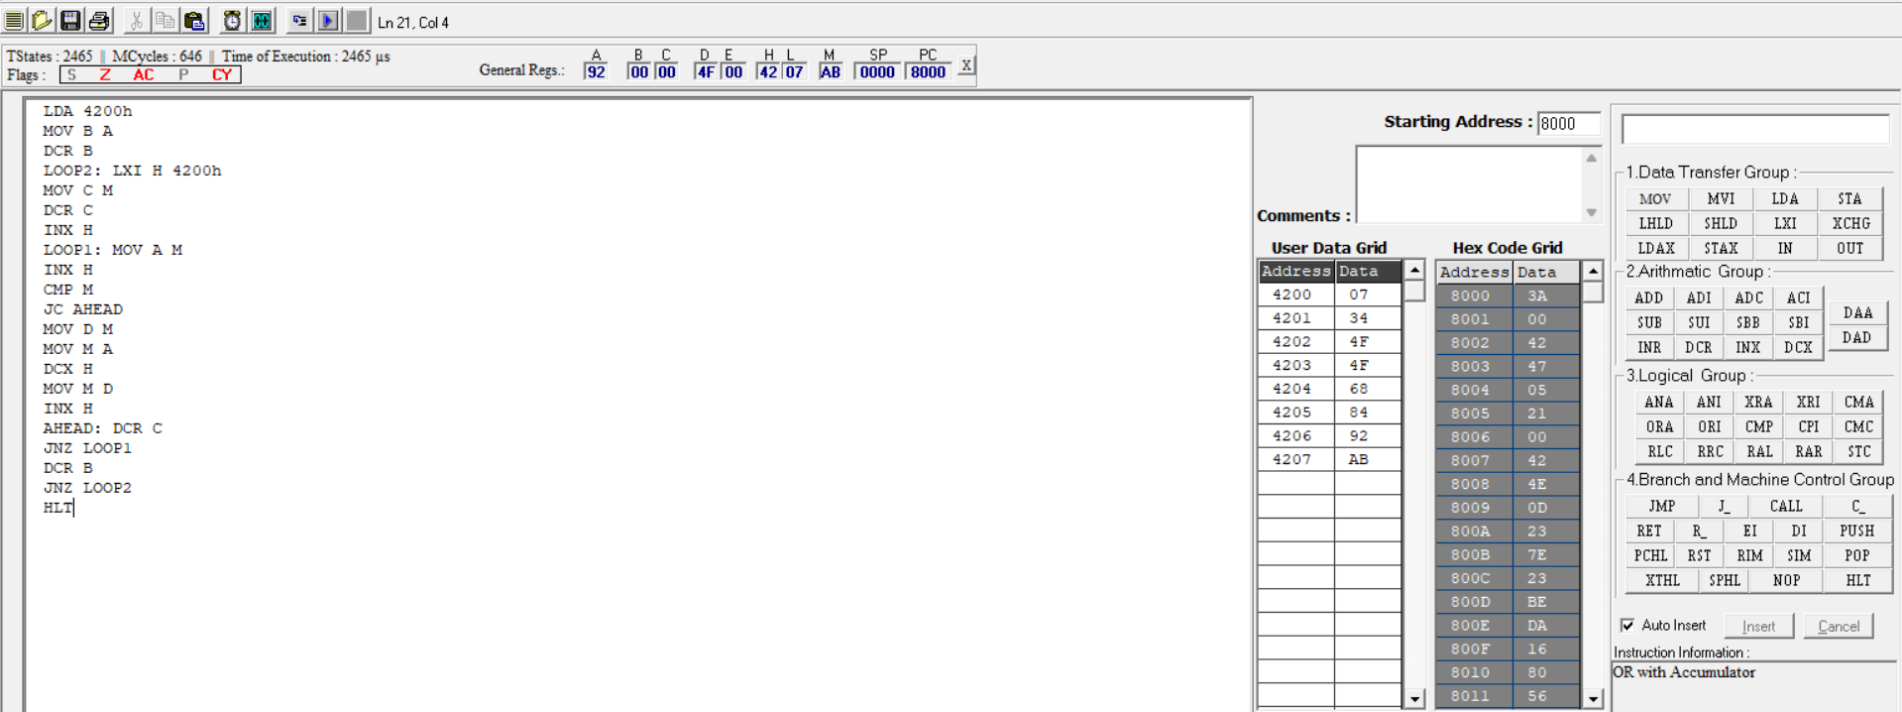
DESCENDING
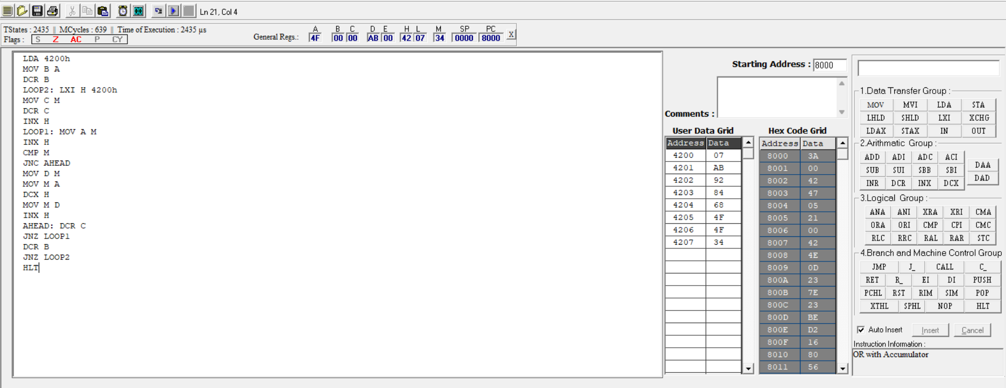
3. ASCII to HEX (BINARY) CONVERSION
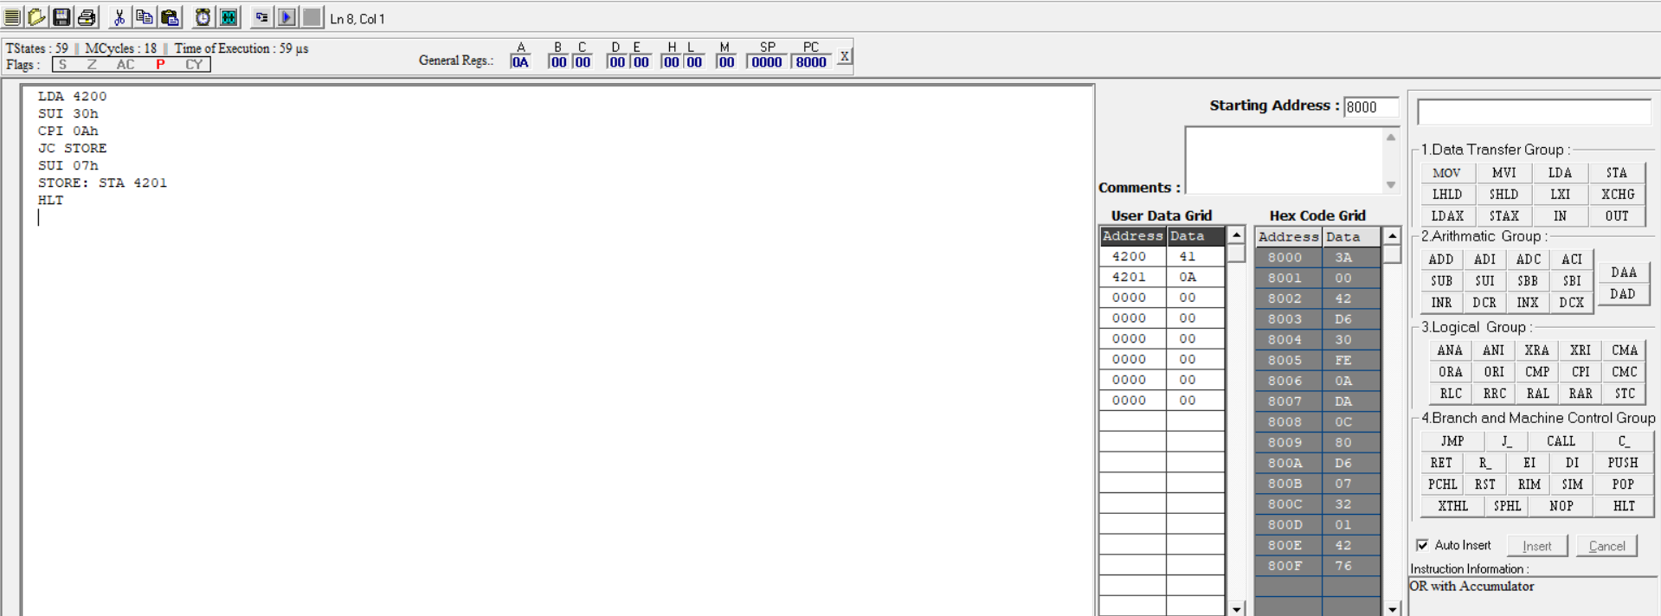

4. TRANSFERRING A BLOCK OF DATA BETWEEN MEMORY LOCATIONS
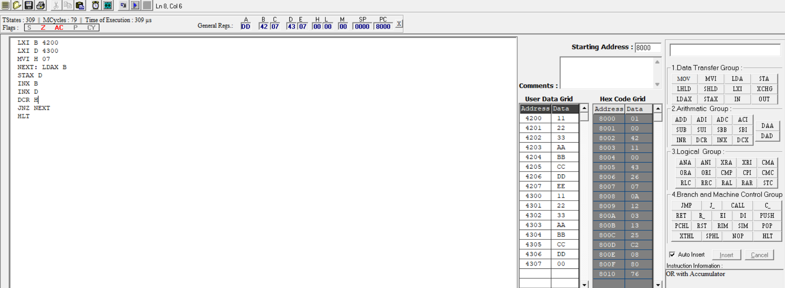
5. MASKING AND SETTING OF LOWER NIBBLES ON GIVEN DATA
a) MASKING
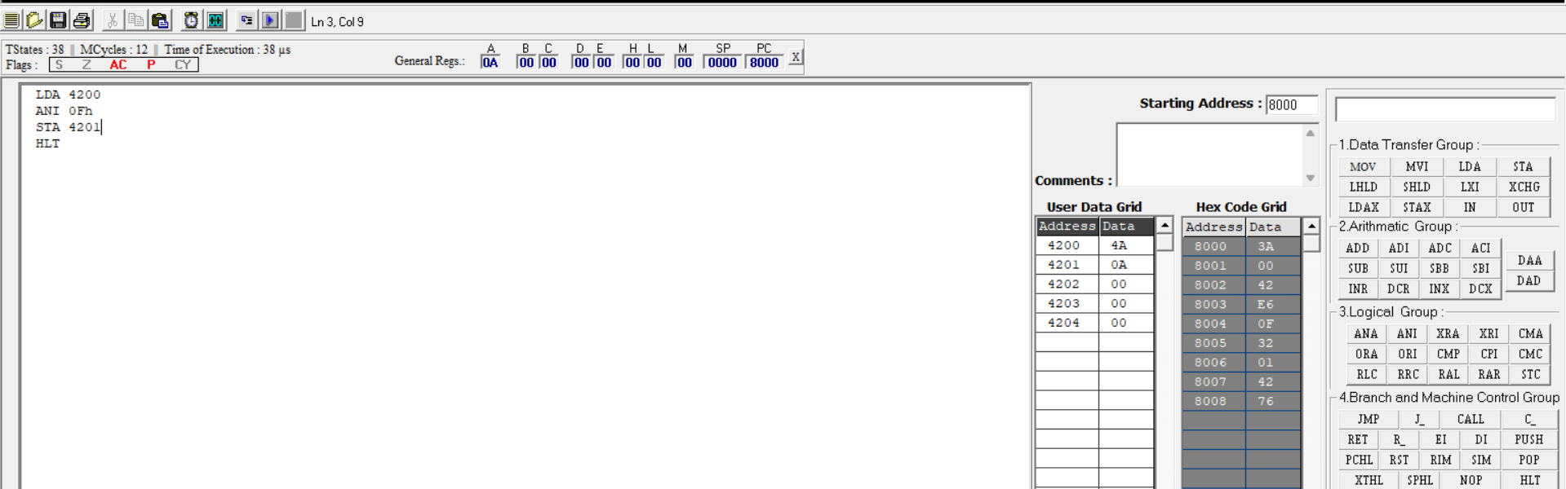
b) SETTING
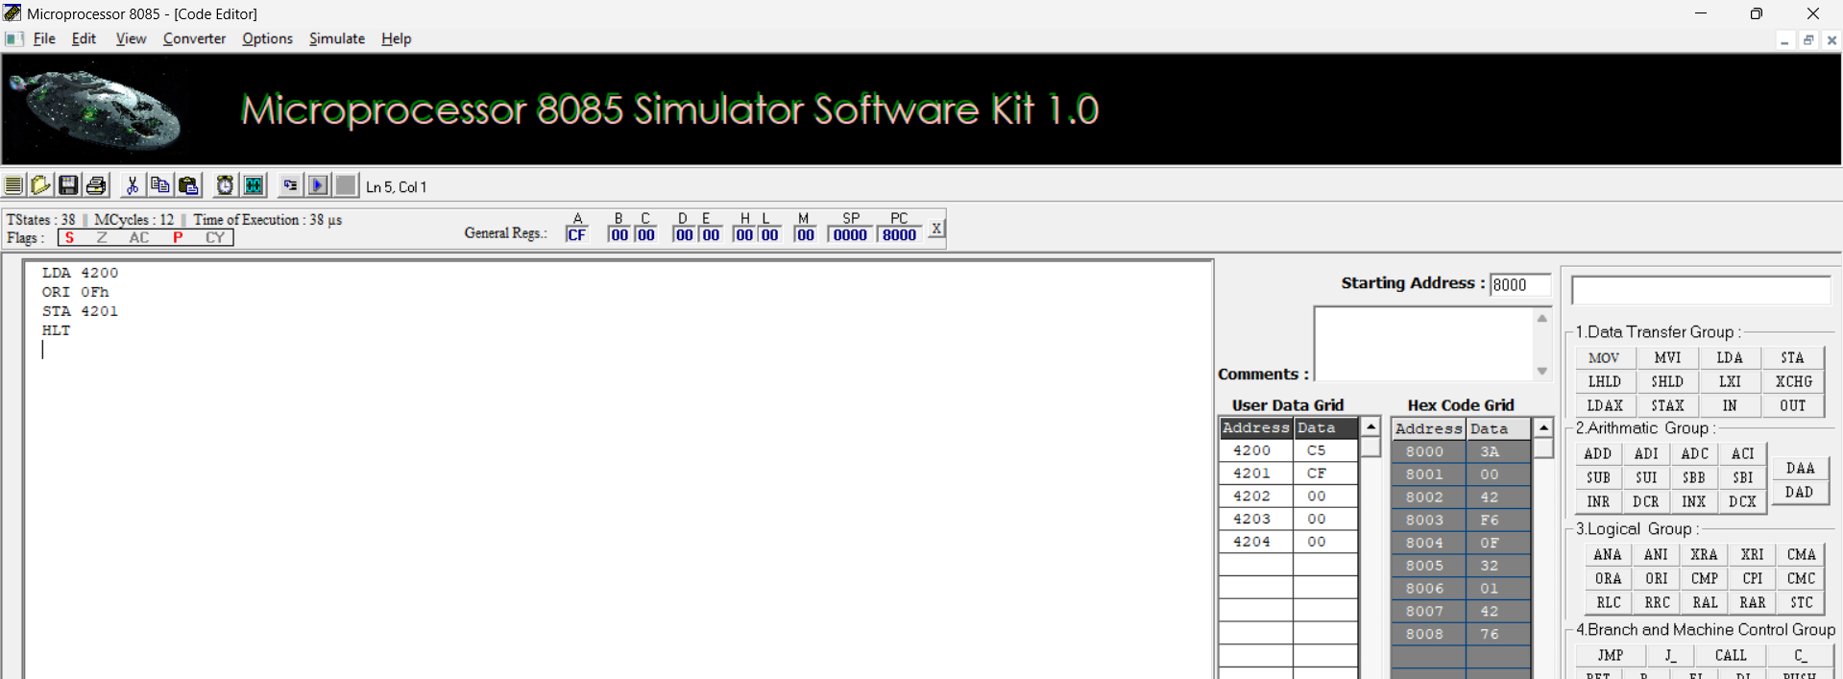

ONES’S AND TWO’S COMPLIMENT
